Project Design Phase
Problem – Solution Fit Template

Date | 01 October, 2026
Team ID | SWTID-2026-3664
Project Name | Script-Controlled ACL – Restrict Record Access Based on Field Value
Maximum Marks | 2 Marks

1. CUSTOMER SEGMENT(S) – CS
- ServiceNow Administrators
- IT Support Teams
- Organizations handling sensitive records
2. JOBS-TO-BE-DONE / PROBLEMS – J&P
- Prevent unauthorized record access
- Control READ, WRITE, CREATE and DELETE
- Restrict access based on roles and field values
3. TRIGGERS – TR
- Attempt to access restricted records
- Change in sensitive field values
- Need for stronger access control
4. EMOTIONS BEFORE / AFTER – EM
- Before: Security concerns and access-management difficulties
- After: Controlled access and improved security
5. AVAILABLE SOLUTIONS – AS
- Role-based access control
- Standard ServiceNow ACLs
- Manual permissions
- Custom ACL scripts
6. CUSTOMER CONSTRAINTS – CC
- Existing ServiceNow configuration
- Limited administrator time
- Security and compliance requirements
- Need for minimal customization
7. BEHAVIOUR – BE
- Users access records through Forms and Lists
- Authorized users perform permitted actions
- Unauthorized users are denied access
8. CHANNELS OF BEHAVIOUR – CH
- Online: Web UI, Forms, Lists, Service Portal
- Offline: Testing and security review
9. PROBLEM ROOT CAUSE – RC
- Role-only access may not be sufficient
- Access may depend on specific record field values
- Manual permission management can be difficult
10. YOUR SOLUTION – SL
- Script-Controlled ServiceNow ACLs
- Evaluate User Role + Record Field Value
- Control READ, WRITE, CREATE and DELETE

Template:
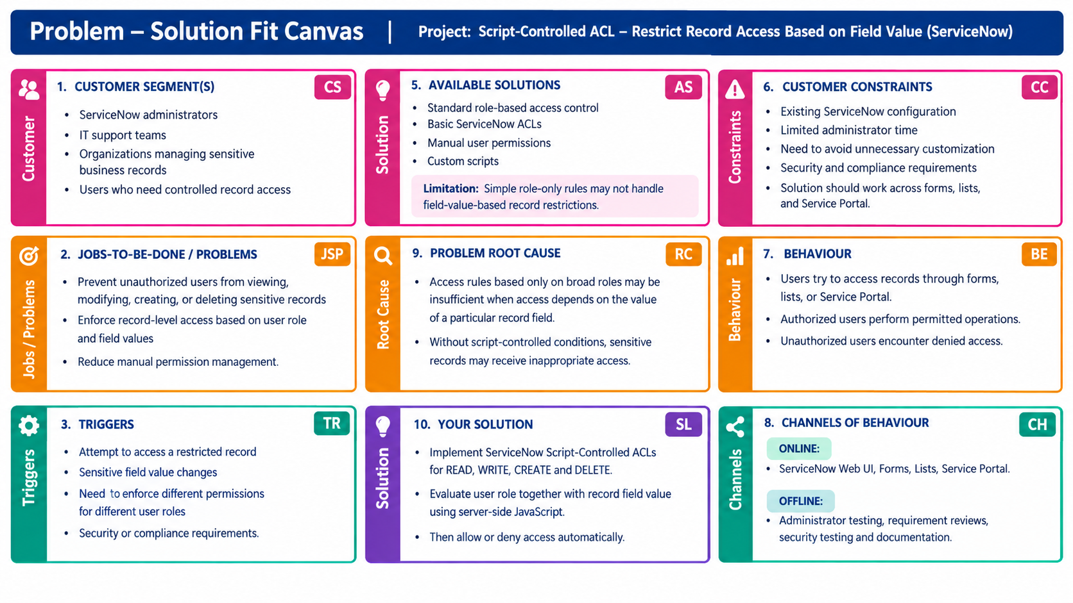

References
- IdeaHackers.network – Problem-Solution Fit Canvas
https://www.ideahackers.network/problem-solution-fit-canvas
- IdeaHackers.network – The Problem-Solution Fit Canvas, Explained
https://www.ideahackers.network/blog/problem-solution-fit-canvas-explained
- Medium – The Problem-Solution Fit Canvas by Daria Nepriakhina
https://medium.com/@epicantus/problem-solution-fit-canvas-aa3dd59cb4fe

